Abstract—A 16 bit multi-cycle datapath processor is designed in which power consumed in the processor is reduced by incorporating a clock gating scheme that gates the flip flops if it’s decided that its output is not required in the current cycle of instruction execution. The technology used in the transistor design is 180nm technology. The amount of power saving has been found to be fruitful which hence validates this simple yet effective scheme.
A Processor design with clock-gating
Its power estimation and saving
Kautalya Mishra

INTRODUCTION
A multi-cycle datapath processes instructions in cycles, numbers of which depends on the type of instruction. A clock feeds into 16 bit registers PCreg, ALUOUTreg, regA, regB, Instruction register (IR), Memory data register (MDR), a Register file and a Memroy, and the Control Unit and activates them every cycle. The control signals generated by the Control Unit helps process instructions appropriately. These instructions flow through the datapath for a given number of cycles before the next instruction is fetched. This cycle of fetch and processing is repeated every clock cycle. The memory in my processor design has been designed like a register file with only 16 registers so as to prevent it from becoming slow and affecting the clock frequency. A multiplication program is used to verify the simulation and also while estimating power and savings.

MOTIVATION
In a given cycle of execution it is observed that not all components that are clocked are actually required to be clocked as their output is deemed unimportant for that cycle. In spite of this these components get clocked and consume high dynamic power. Hence a clocking scheme that clocks the components only in a given cycle and gates them otherwise has been introduced to lower the dynamic power and hence also the total power consumed by the processor.

gating scheme
The clock input to a register is drawn out from an AND gate that ANDs the processor clock with a control signal generated by the control unit. The control signal has a logic value ‘1’ only when it is decided that it is necessary to clock the component in that cycle of instruction execution.
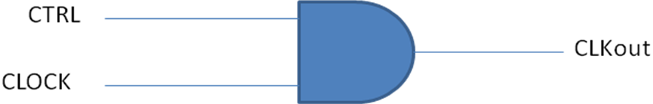

The components gated are regPC, regA, regB, ALUOUTreg, IR, MDR, Register file and Memory.
The figure below shows the multi-cycle datapath with the clock-gating scheme incorporated.
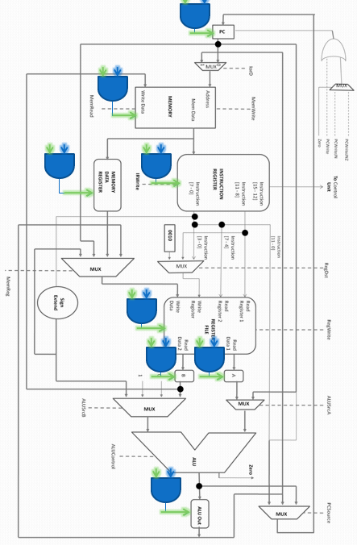

VHDL CODE
The VHDL code written for the component was done so in ‘Modelsim’ and simulation for verification done in the same. The basic idea is to logically AND the incoming clock signal with a control signal before sending it to the component.
The toplevel entity would resemble the figure shown below.
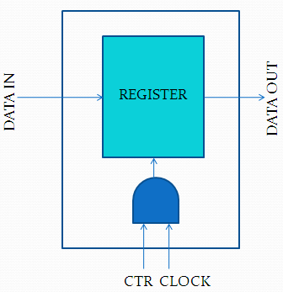

The VHDL code for a single 16-bit register
is coded as shown below.

entity reg16_cg is
port( ctr,clk,reset: in std_logic;
Ain: in std_logic_vector(15 downto 0);
Aout: out std_logic_vector(15 downto 0)
);
end entity reg16_cg;

architecture reg16_cg of reg16_cg is

component clkgate is
port( ctr,clk: in std_logic;
clkout: out std_logic);
end component clkgate;
signal clkin: std_logic;
begin
gating: clkgate port map(ctr,clk,clkin);
process(clkin,reset)
begin
if reset='0' then
Aout<="0000000000000000";
elsif(clkin'event and clkin='1')then
Aout<= Ain;
end if;
end process;
end reg16_cg;

entity clkgate is
port( ctr,clk: in std_logic;
clkout: out std_logic
);
end entity clkgate;

architecture clkgate of clkgate is
begin
process(clk,ctr)
begin
clkout <= ctr and clk;
end process;

As shown above for a single 16-bit register, a control signal ‘ctr’ generated by the Control Unit is sent to a component ‘clkgate’ along with the clock input and the output of that component is feed in as the clock input to the register.
Earlier when I had started I had my program coded a little differently. I had my control signal ‘ctr’ entered in the process sensitivity list but instead of just ANDing the clock with it I had introduced an ‘if’ statement that would allow the program to enter only if ctr =1. But this in Design Architect was not interpreted as an AND as I was expecting it to but interpreted as a ‘MUX’ with the clock still going directly into the flipflops. I hence had to re work my code and write it as shown above.
One other change was also made in the processor with gated flip-flops with the introduction of gating, which was to have a reset input for all clocked components. The reason being that, with the gating scheme only a few components were being clocked while the rest without a reset input would still hold their initial undefined values. These undefined values ‘U’ would then enter the datapath as unknown values ‘X’ and disturb the functioning of the processor. By introducing a reset input for all clocked components we avoid ‘U’ and ‘X’ from flowing in to the datapath.

SIMULATION VERIFICATION
Before estimating power saving over the original datapath design we validate the clock gating design scheme. This was done by running two programs; the first a 2 16-bit signed multiplic-ation program and the second a random program that loads numbers and adds them successively. Both were found to run correctly giving results at the same instant as they would have given in the original datapath.

The figure above shows the clock signal being gated by the control signal ‘ctr’ and the clkout signal that feeds into the component. A glitch in the ‘clkout’ signal can be seen every time the ‘ctr’ signal makes a falling transition. This is unavoidable as means of removing it introduced additional complexity and delay that affected the simulation.
A multiplication program was run to verify the clock-gating design and 2 16-bit numbers, in my case 7 and 3, were multiplied and their result 21 stored in the register file. The simulation was verified with correct result being stored in the register file the same instant at which the original datapath would have stored the result. The only difference being that the ‘outvalue’ signal produces the result for an arithmetic instruction one cycle earlier for the gated datapath. This is not of concern as the data is still written into the register file at the same instant but only read out of the register file a cycle earlier.
The figure below is the list file for the original datapath and the subsequent list file for the gated datapath.

POWER ESTIMATION
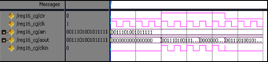
I started off by attempting to estimate power in the processor using the ‘POWERSIM’ tool. The VHDL file simulated on MODELSIM was first converted to a Verilog format using Leonardo Spectrum and then converted to a ‘Rutgers’ mode format using the converter tool that comes with Powersim. The simulation however showed a segmentation. Earlier in my design I had incorporated a memory designed using the Mega wizard tool in Quartus and thought it to be the reason for the segmentation fault as the instructions weren’t embedded in this memory format and had to be read from another file. I then redesigned my memory as a register file with instructions embedded in it. Again however a segmentation fault was encountered and the simulation failed. I then decided to estimate the power in Powersim component by component with the input vectors being what it would have been had the processor been functioning in its normal mode.
In this I did not consider loading the components which they should have had as they feed into subsequent blocks if placed in the datapath.
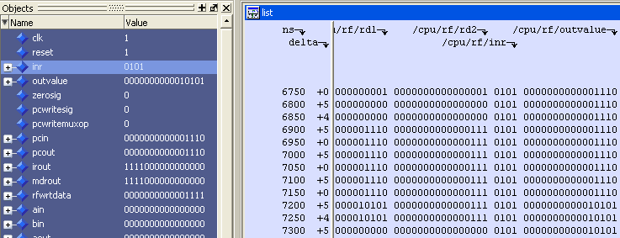
Powersim did simulate these components with the exception of the Control Unit which again showed a segmentation fault, which implies that the segmentation fault obtained earlier was because of the Control Unit. I also continued estimating power for the other components. The results obtained however were awry. I believe it is because Powersim expects close to exact values of all the gate delays for the component to be feed into it. This for my processor would have been impractical as the numbers of gates alone were close to 4500 and designing the gates in SPICE and estimating the delays for a specific input vector would require a lot of time. I also hence did not spend much time in redesigning the Control Unit so as to avoid the segmentation fault earlier encountered.
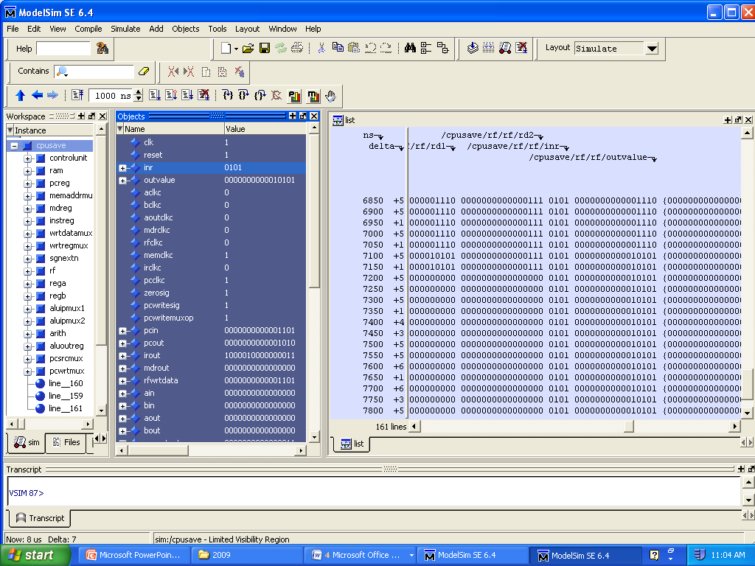
Instead, I decided to switch to measuring power using HSPICE, for which the gate level netlist generated in Leonardo Spectrum had to be converted to a transistor level netlist in Design Architect and then simulated for power in HSPICE. Here again the input vectors feeding into the components were obtained from the list file in Modelsim that had a list of the signals flowing through the datapath for the multiplication program.

RESULTS
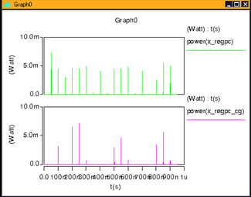
Results depicted below were obtained by simulating the transistor level netlist in HSPICE and estimating power. Input vectors given to the components are those that would have gone in as input had the component been placed inside the datapath and the multiplication program run.
Initially only 10 input vectors were given as inputs in Spice and the power was estimated. The table below shows the dynamic power and the leakage power consumed in the two cases.

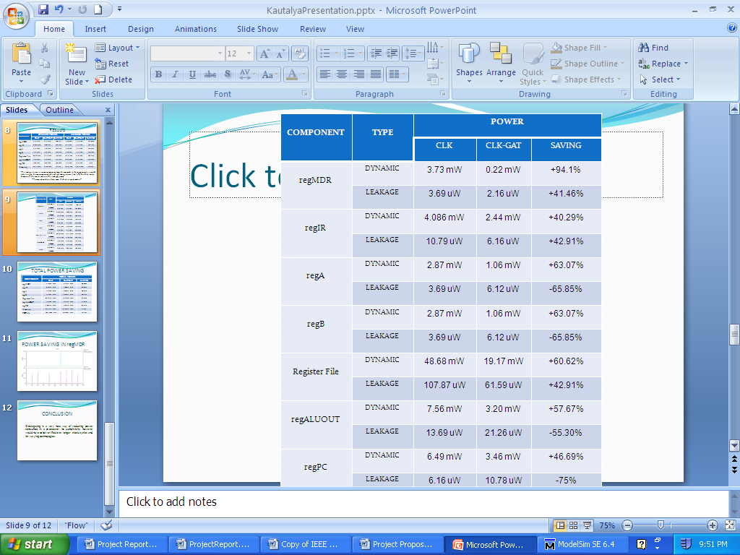
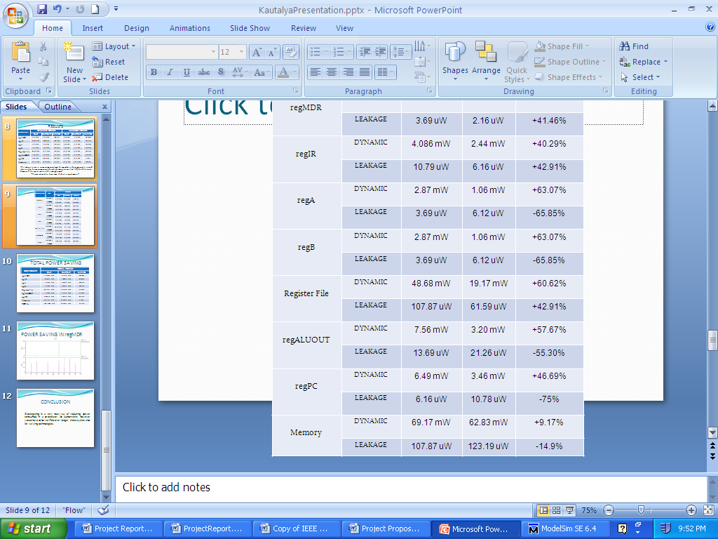
TABLE

We observe from the table that while the dynamic power sees a lot of saving, leakage power in some cases is higher in the clock gated scheme. This I believe occurs because of the larger OFF period the components have to stay in hence allowing a longer duration for the leakage current to flow through.
The Total Power saving calculated by adding the dynamic power and the leakage power is found to be 35.79%. In spite of getting high savings in most individual components the not very high saving in the Memory overshadows the high saving in other components because of its larger value and hence brings down the total power saving to 35.79%.
The power waveform for regPC is shown below.

We clearly see that the numbers of spikes that correspond to the dynamic power are a lot lesser in the clock gated scheme than in the original register without any gating. The leakage power however if magnified is seen to have increased in the gating scheme. Similar waveforms were obtained for other components with the numbers of spikes getting drastically reduced.
I also simulated HSPICE for a few components for all 166 vectors that are necessary for the multiplication program and observed similar results. The following power waveform was obtained for regPC for the 166 vector input.
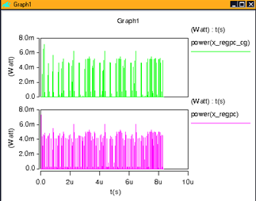
Again we see that a number of the power spikes are missing in the clock gating scheme while the magnitudes haven’t changed by much.

CONCLUSION
Clock-gating is a very neat way of reducing power consumed in a processor. Its authenticity however would have to be verified over varying technologies where the ratio of Leakage to Dynamic power is a lot higher than it is in 180 nm technology.

REFERENCES
- Dr.V.D.Agrawal course website for ELEC6270 http://www.eng.auburn.edu/~vagrawal/COURSE/E6270_Spr09/course.html

 

